Milestones:

MP1 Gantt Chart task

BILL OF MATERIALS 10/20/17 to 10/27/17

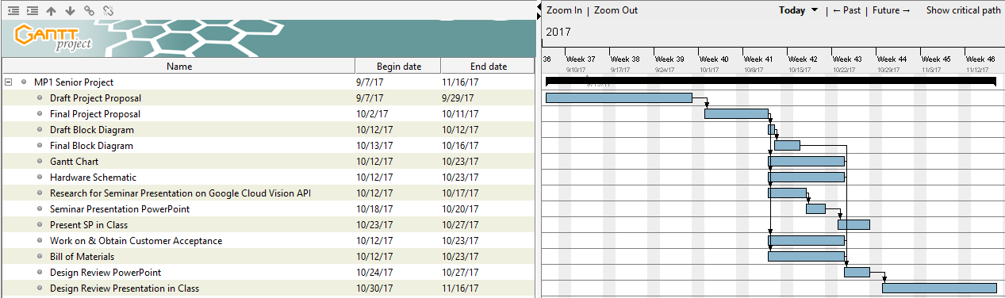

MP2 Gantt Chart tasks

* MP2 11/18/17 to 2/1/18
* Obtain camera and microcontroller 11/18/17 to 11/30/17
* Interface camera and microcontroller 11/30/17 to 12/10/17
* Discuss and Finalize Contract with Mr. Paterno
* Test Google Cloud Vision API with our own images 11/18 to 11/21/17
* Interface Cloud Vision and microcontroller 11/18/17 to 12/15/17
* Over Break (12/18/17-1/3/18)
  + Complete first version of code
* Test Code for all cases 1/1/18 to 1/15/18
* Start looking at/ordering supplies for the hardware aspects 1/3/18 to 1/20/18
* Add in

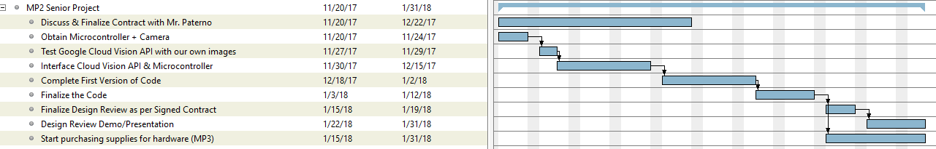

MP3 Gantt Chart

* 2/2/18 to 4/11/18
* MP3 Contract (variable depending on Mr. Paterno’s schedule) 2/2 -> 2/28
* Start building the hardware aspects
  + Complete Pressure Sensor-Input Mechanism 2/2 to 2/9
  + Complete Mechanical Aspects of Conveyor Belts 2/12 to 2/23
* Integrate software and hardware (Building final product for DR) with electrical aspects (wiring, connections, etc.) 2/24 to 3/20
* Final touches for DR
* Testing for integration and fine tuning 3/15/18 to 3/30/18
* Examine 3D Printing 4/1/18 to 4/11/18
* Examine PC Boarding 4/1/18 to 4/11/18

MP4 Gantt Chart 4/18/18 to 6/22/18

* 3D Printing 4/11 to 4/30
* PC Boarding 4/18 to 5/10
* Extensive Testing on various inputs and defensive programming for reliability 4/30/18 to 5/20/18
* Fine tune mechanical parts and software as necessary 4/30/18 to 5/20/18
* MP4 Video 5/10/18 to 6/2/18
* Final touches on product for MP4 Design Review 5/20 - 6/3